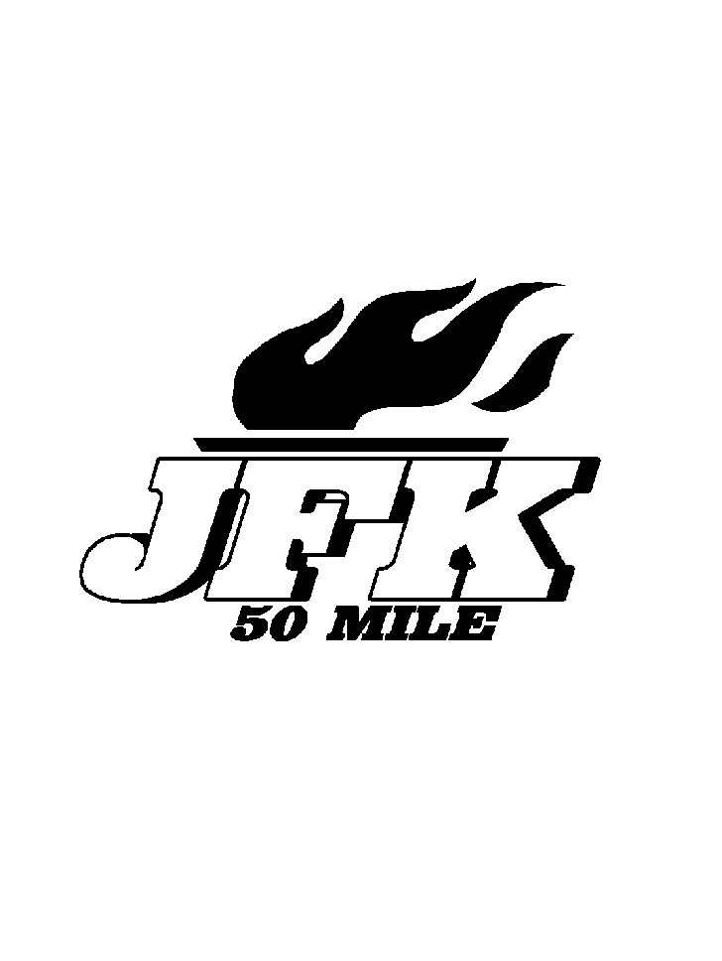
Old Line Graphics & Logo
11808 Bradford Drive ~ Hagerstown, Maryland ~ 21742 ~ 301-791-8959
Email – areid@myactv.net

Orders must be received no later than December 31, 2008 orders will be shipped the beginning of February

Name Phone number

Ship to address

Item Description | Color(s) | Size(s) | Quantity | Price | Sub -Total
Devon & Jones Mock Turtleneck  Colors – Navy or Grey |  |  |  | 30.00
Devon & Jones Tipped Polo  Colors – Stone, Navy, Red |  |  |  | 35.00
Hooded Sweatshirt  Colors - Navy or Grey |  |  |  | 30.00
Crewneck Sweatshirts  Colors - Navy or Grey |  |  |  | 25.00
Charles River Jacket  Colors - Black, Grey or Red |  |  |  | 50.00
Runners Cap  White, Grey or Navy |  |  |  | 15.00
Reflective Brim Hat  Colors – Navy or Red |  |  |  | 15.00
Fleece Beanie  Navy only |  |  |  | 15.00
Navy Sandwich Bill Hat |  |  |  | 15.00

Total # of items ordered Total Enclosed $

Prices above include shipping costs

Make Checks Payable to:
Old Line Graphics & Logo

Visa/Master Card Information
#________________________ Exp. Date _____________

Mail this form along with payment to:
Old Line Graphics & Logo
11808 Bradford Drive
Hagerstown, MD 21742

