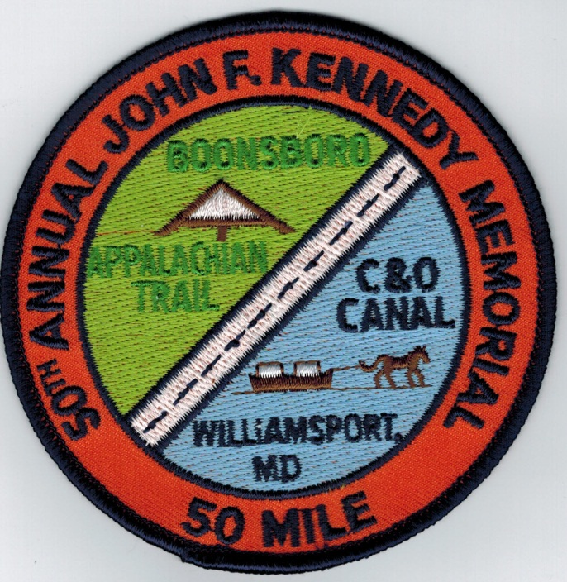
Running the 50th annual JFK November 17th 2012?
Order your commemorative patch now.
Send $9.00 CASH or MONEY ORDER ONLY TO:
Paul Betker
13202 Unger Road
Hagerstown, MD 21742

Traditional patches also available without the 50th annual wording

